***What is systemic practice?***

We asked one Consultant Social Worker for her experience of working systemically in a Social Work Unit. This is what she said:

"*For me as a CSW I initially found the role very varied and challenging. As well as managing a Unit and the cases that the Unit holds, I was also case working and modelling good practice and coaching/ developing the members in my unit especially in terms of systemic practice. Within our LA we had forums in which specific roles would meet to share ideas, learn from each other and trouble shoot; I belonged to the CSW forum but every role had access to their own. This alongside less formal support networks was really crucial in helping me to develop and be confident within my role.*

*I would also say that I noticed professionals from other agencies that we worked alongside feeling and sometimes stating their anxiety about change within CS structures and the way we practiced (e.g. sometimes professionals misunderstood increased curiosity about risk within family as condoning of abusive parenting). This was sometimes frustrating and difficult to manage. At a local/ unit level we would be very aware to be transparent and inclusive in our thinking with other professionals and have an open invitation for them to join our unit meetings to discuss co-worked families*. "

Consultant Social Worker

Hackney Borough Council

Reclaiming Social Work advocates a systemic way of thinking about and working with families and children. A systemic approach focuses on relationships and interactions in the family and wider systems, including those of the professional.

***What is the connection between Reclaiming Social Work and systemic practice?***

Reclaiming Social Work in Aberdeen

3 : Systemic practice

Morning Lane Associates, who have led the development of Reclaiming Social Work from its first inception in Hackney in London, describe it as “an innovative model aimed at re-invigorating social workers to effectively intervene in families - keeping more families together safely. Reclaiming Social Work equips social workers with evidence based tools from the field of systemic family therapy and social learning theory; supports them with expert and intensive case supervision; provides outstanding business support; reduces bureaucracy; and devolves decision making, meaning that families get the right support, in the right moment, to make and sustain changes.”

***Why systemic practice?***

Reclaiming Social Work sees a move away from the traditional format of a ‘Social Work Team’ to the formation of small multi-skilled Social Work Units. Each of these Units will have a Consultant Social Worker, who manages the Unit and is responsible for the Unit’s caseload. Although the Consultant Social Worker retains overall responsibility for the caseload, other Unit members may take the lead on some cases. An important feature of this model is that each member of the Unit knows the children and families being worked with and work as a team to co-ordinate and support interventions.



The benefit of this whole system approach is that the Unit draws from the collective perspectives and expertise of everyone and workers are not left with individual responsibility for assessing and responding to the needs of families. This approach provides more scope for critical reflection and evaluation of work and in doing so enables the Unit to make more comprehensive assessments of risk and clearer outcome focused care plans.

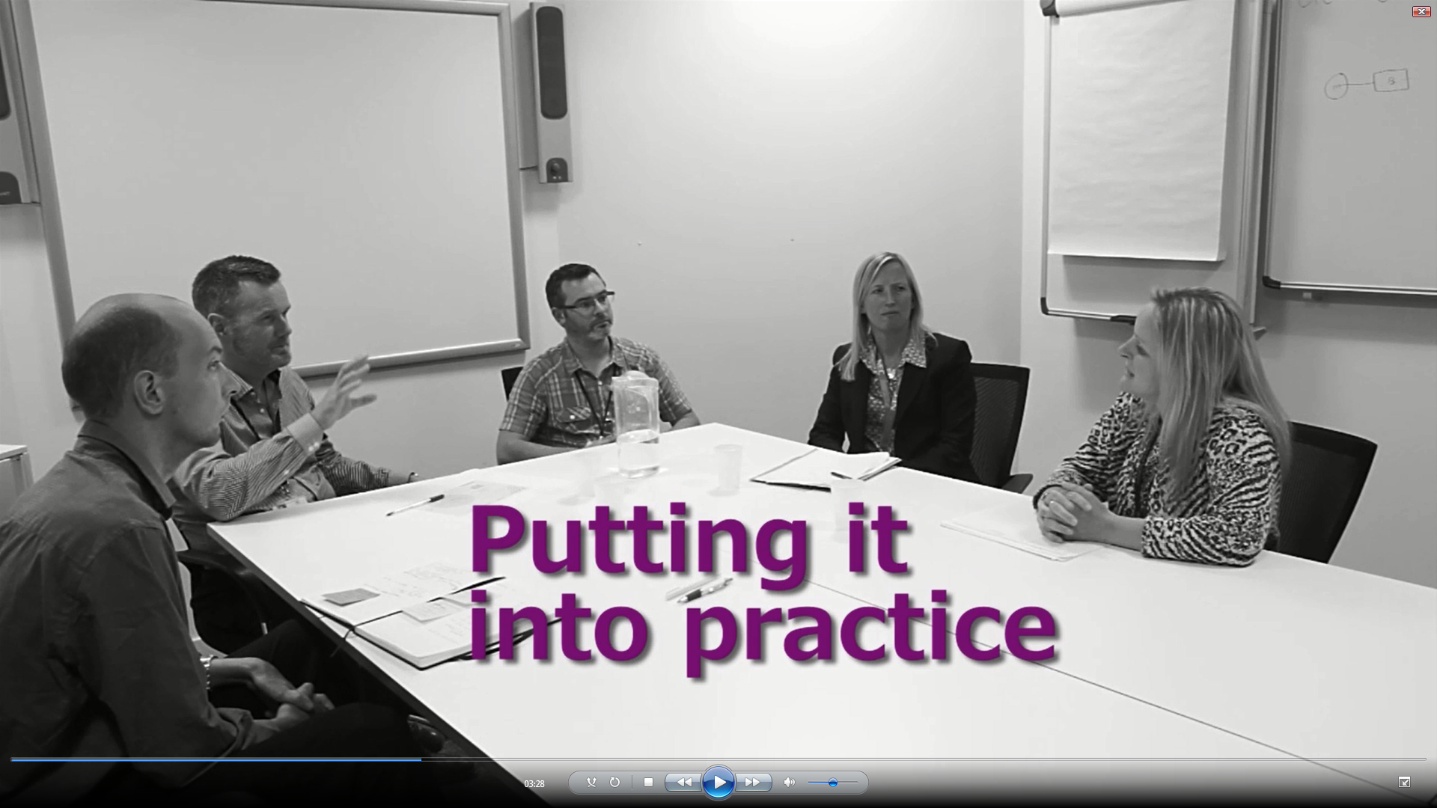

It also benefits families, with workers having more opportunities to provide therapeutic support and to work directly with families to build on strengths and reduce risks. The model aims to place families at the centre and work with them to make sustainable changes. It promotes the belief that parents want the best for their children and aims to help families identify unhelpful patterns of behaviour, supporting them to make changes within their own social context.

***Accredited training in systemic practice***

In order to develop a skilled and confident work force a commitment was made to provide social work staff with AFT accredited training on systemic practice. The training is delivered over the course of a year, with 12 teaching days. Participants are required to complete an assessed essay and portfolio in order to gain accreditation.

“The commitment to provide systemic training to all social work staff in Aberdeen will support the service to grow a work force that is familiar with a systemic and social learning framework and knowledgeable on a range of evidence based interventions.”

Bernadette Oxley, Head of Children’s Social Work

Participants develop a good working knowledge of systemic frameworks and interventions and have opportunities to reflect on case work and consider how the approach may be applied to working with children & families in complex situations. The course explores the influence of culture and the wider social context on families as well as practitioners, challenging our perspectives, belief systems and approaches to family work.

***The role of clinician in the Social Work Unit***

The introduction of a half time clinician in each Social Work Unit provides the added benefits of a worker who can provide consultation and clinical expertise to other Unit members, an alternative perspective to case discussions which maintains a focus of systemic thinking, as well as being able to deliver a therapeutic service to children and families where this need is identified. A further year of training is provided for the clinical practitioners.

Reclaiming Social Work in Aberdeen

|  |  |  |
| --- | --- | --- |
|  | *For more information about Reclaiming Social Work in Aberdeen or about jobs in Children’s Social Work in the city please contact us by e-mail:* [*together@aberdeencity.gov.uk*](mailto:together@aberdeencity.gov.uk) *or by phone on 01224 522533 or at our website http://www.aberdeencity.gov.uk/jobs_careers/jobs_and_careers.asp* |  |